TCYBA Defensive Rules

The purpose of this document is to help coaches, officials and players understand the LTAD modifications that will be in effect at the TCYBA Development level of play.

- No 30 second shot clock – rationale: It reduces the pressure of decisions made due to the clock; able to involve more players per possession in movement, spacing and handling the ball.
- No zone – rationale: Encourages movement; allows for creativity with the ball, passing, cutting and penetration; more time can be spent in practice on the mastery of basic fundamental principles of play in both offence and defence.

Spirit of the rule
It is expected that everyone involved understands the reasoning behind the rules. Players at this stage are still at the Learn to Train Stage and moving into the Train to Train stage within our LTAD model. The focus is on training to become a multi-skilled, multi-positional player. The focus is also to provide players with the opportunity to be successfully individually at this early development stage and allow them to penetrate to the basket without having to deal with the decision making required when dealing with a secondary defender.

The purpose of this document is not to provide coaches with a means to find loopholes in the rules and thereby develop elaborate strategies that play on the edges of the rules. Coaches are to use the document to clear up any misunderstanding of what will or will not be called.

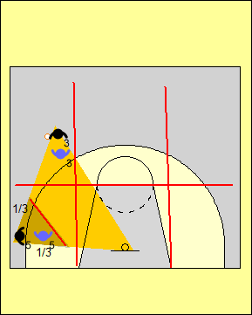 | The front court is divided into six grids by a line extending across the foul line and two lines running up from the baseline where the FIBA key meets the baseline.  A triangle is formed by the defensive player with the three points of the triangle being the ball, his/her check and the basket. When a defensive player is in the same grid, a grid above, below or beside the offensive player with the ball, this defender can be:  - No further than 1/3 the distance on the line between his/her check and the ball ( Approximately 2 metre’s form their check)  - No further than 1/3 the distance on the line between his check and the basket.  The defender can be in an open or closed stance. A player may not go to double team or stunt and if he/she remains stationary in the restricted area it will be deemed an illegal defense.
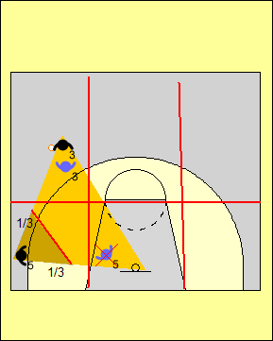 | In this example the defender is stationary. Although he/she is still only 1/3 of the distance off the line between the ball and his/her check, he/she is clearly more than 1/3 of the distance to the basket and not within 2 metre’s of his/her check.. This would be called an illegal defense.  It is obvious when a player is out of position.
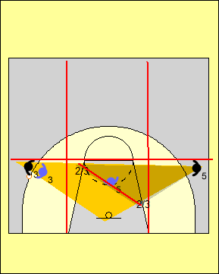 | When a defender is in a grid diagonally to or not touching the grid with the ball in it, the defender can be:  - No further than 2/3 the distance on the line between his/her check and the ball  - No further than 2/3 the distance on the line between his check and the basket.  This means a player can assume good help position in the key with two feet in the in the centre grid and be in a legal defensive position. The helpside defender may also  impede the offense player on the other side of the court from driving to the basket but two players may not trap the ball carrier after halt that drive by rotating and individually guarding a player.
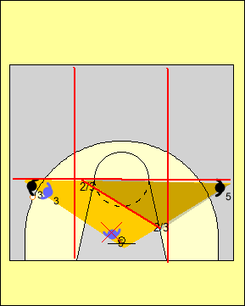 | In this example the defender is guarding the basket which means he/she is more than 2/3 of the distance between his/her check and the basket. As before, the defender is allowed to be stunting in and out of the restricted area. He/she cannot remain stationary.
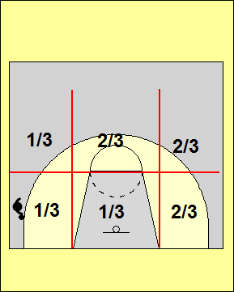 | 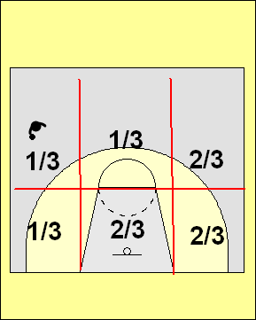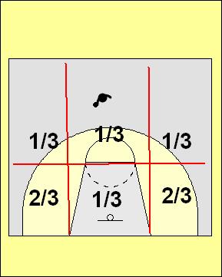
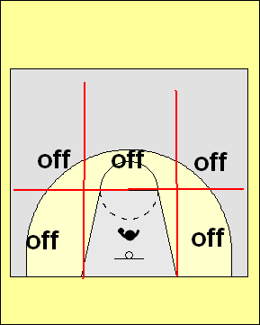 | The restrictions on zone defence will be considered off when:  - The ball is passed into the key  - Penetration towards the basket occurs by the dribble  - A shot is taken  - An offensive rebound is gained. Once the offence re-establishes their formation the zone rule is back on.  - Teams use extreme offensive formations to play on the edges of the rules. It is not the offensive coach’s role to expose zone defences.  If an offensive player is in the grey area between two grid lines, the leeway will go to the defender, as if he/she should be in the 1/3 or 2/3 position.

Defensive Transition

Players may fall back to a designated pick up point. Players may defend the basket until defensive help arrives. Defenders whose offensive check trails behind the ball may defend in front of the ball. Once their check passes the ball handler the 1/3, 2/3 rule comes into effect.
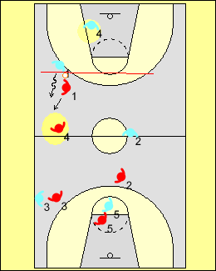 | Defender #4 is able to shadow ball handler #1 since his/her check #4 is trailing behind the ball in transition but must not double team.  The players in front of the ball are observing the 1/3, 2/3 rule.
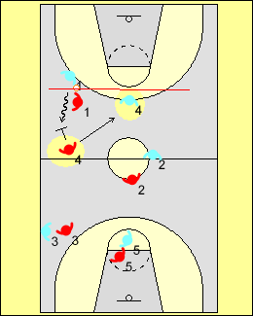 | In this example defender #4 move to double team the ball which is illegal in the TCYBA. As offensive player #4 moves in front of the ball, defender #4 must observe the 1/3, 2/3 rule as designated by the arrow in the diagram. If a player continues in a double team and doesn’t pick up their check, he/she will be considered to be playing a zone.  Help defense and rotations are allowed, but must come out of player to player principles.

