TCYBA Defensive Rules

The purpose of this document is to help coaches, officials and players understand the LTAD modifications that will be in effect at the TCYBA Development level of play.

- No 30 second shot clock – rationale: It reduces the pressure of decisions made due to the clock; able to involve more players per possession in movement, spacing and handling the ball.
- No Double Team or Illegal Defenses – rationale: Encourages movement; allows for creativity with the ball, passing, cutting and penetration; more time can be spent in practice on the mastery of basic fundamental principles of play in both offence and defence. Presents decision making situations at an appropriate cognitive and physical maturation level for the athletes participating.

Spirit of the rule
It is expected that everyone involved understands the reasoning behind the rules. Players at this stage are still at the Learn to Train Stage and moving into the Train to Train stage within our LTAD model. The focus is on training to become a multi-skilled, multi-positional player. The focus is also to provide players with the opportunity to be successfully individually at this early development stage and allow them to penetrate to the basket without having to deal with the decision making required when dealing with a secondary defender.

The purpose of this document is not to provide coaches with a means to find loopholes in the rules and thereby develop elaborate strategies that play on the edges of the rules. Coaches are to use the document to clear up any misunderstanding of what will or will not be called.

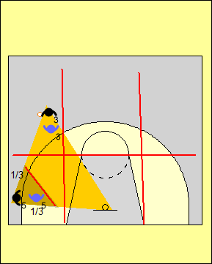 | The front court is divided into six grids by a line extending across the foul line and two lines running up from the baseline where the FIBA key meets the baseline.  A triangle is formed by the defensive player with the three points of the triangle being the ball, his/her check and the basket. When a defensive player is in the same grid, a grid above, below or beside the offensive player with the ball, this defender can be:  - No further than 1/3 the distance on the line between his/her check and the ball ( Approximately 2 metre’s form their check)  - No further than 1/3 the distance on the line between his check and the basket.  The defender can be in an open or closed stance. A player may not go to double team or stunt and if he/she remains stationary in the restricted area it will be deemed an illegal defense.
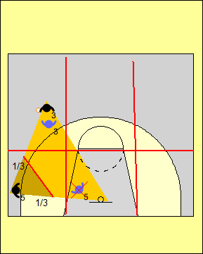 | In this example the defender is stationary. Although he/she is still only 1/3 of the distance off the line between the ball and his/her check, he/she is clearly more than 1/3 of the distance to the basket and not within 2 metre’s of his/her check.. This would be called an illegal defense.  It is obvious when a player is out of position.
 | In this example the defender is guarding the basket which means he/she is in an illegal defensive position.
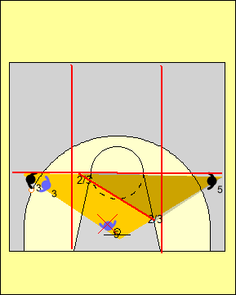 | When a defensive player is in a grid diagonally to or not touching the grid with the ball in it, the defender must be:  - Must have at least one foot in the same grid as his/her check and on the line between his/her check and the ball  - The Defender must maintain an approximate distance of 2 metre’s from his/her check and may not sprint to help or double team when the ball is driven to the basket.  This means the player in this diagram, while playing what many would perceive as help side defense at the high school or Rep level, is more than 1/3 of the distance to the ball and is in an illegal defensive position at the development level of the TCYBA. The help side defender could have one foot in the centre grid and be in a legal defensive position but may NOT impede the offense player on the other side of the court from driving to the basket.
To summarize, defensive players must be within 2 meters of their check in the back court and help defense that involves a defender that is guarding an offensive player away from the ball engaging the player with the ball is not permitted.

